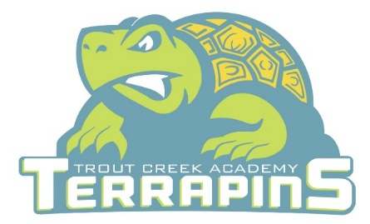
Trout Creek Academy
Kindergarten Supply List
2026-2027 School Year
Quantity | Item Description
4 | Boxes of Crayola crayons 24 ct
12 | Expo dry erase markers -fine point- Black
12 | Elmers washable glue sticks (standard size)
2 | Packs of Ticonderoga No. 2 pencils, sharpened 12 pack (24 total)
1 | Crayola washable markers, thick, classic colors 8 ct
1 | Scissors (Kids sized & blunt tipped)
1 | Pair of wired headphones (not ear buds/Bluetooth, must have cord to plug in)
2 | Full size Play-Doh cans
1 | Plastic pencil box
1 | 4x6 Index cards colored or white
3 | Primary journals (picture space on top and lines on the bottom)
4 | Large pink erasers
1 | Yellow 2-pocket poly (plastic) folder with clasps
1 | Pack of clear page protectors
1 | Pack of baby wipes
1 | Pack of bandages
1 | Pack of Post-it notes
2 | Yellow highlighters

Girls-
1 Pack of cardstock

Boys-
1 Pack of assorted color construction paper

Resource-
Crayola watercolor set for art

